
Women in Danger
PRESENTS

Stories by Jamil Jan Kochai and Priya Balasubramanian
Read by professional actors

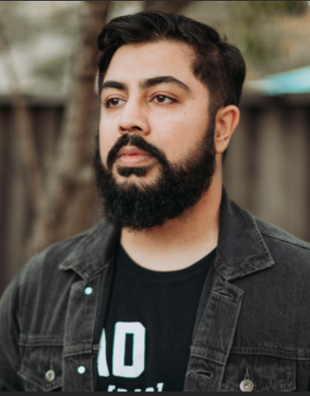

Friday, July 18 at the Auditorium at CLARA 24th and N Streets
7PM, doors open at 6:30 $10 donation

Join us for an evening of prize-winning fiction guaranteed to keep you on the edge of your seat. In Jamil Jan Kochai’s story “Enough,” the elderly Rangeena is suffocated and haunted by past trauma. In Priya Balasubramanian’s tale “Flowers for Kamala,” a very young woman must make a hazardous decision. In both stories, the women fight to preserve their lives and sense of self against overwhelming odds.

